|  |  |  |
| --- | --- | --- |
| Q1 | 1. What are the cache actions that checked first to determine if information is there?  * If it is, information used directly from the cache (fast) * If not, data copied to cache and used there  1. What is the difference between Asymmetric clustering and Symmetric clustering? Then draw the Clustered System.  * Asymmetric clustering has one machine in hot-standby mode * Symmetric clustering has multiple nodes running applications, monitoring each other  1. Which of the following instructions should be privileged?  * Set value of timer. * Clear memory. * Turn off interrupts. * Modify entries in device-status table. * Access I/O device. |  |
| Q2 | 1. Draw the block diagram of the transition from User to Kernel Mode? 2. List the process management activities?  * Scheduling processes and threads on the CPUs * Creating and deleting both user and system processes * Suspending and resuming processes * Providing mechanisms for process synchronization * Providing mechanisms for process communication * Providing mechanisms for deadlock handling |  |

Q1: B)

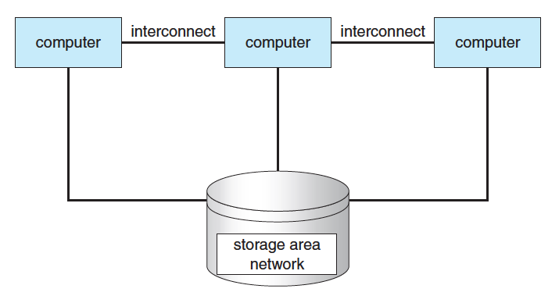

Q2: A)

